07 BANK DATABASE – SQL VIEWS
2520089071

- Customer + Account View
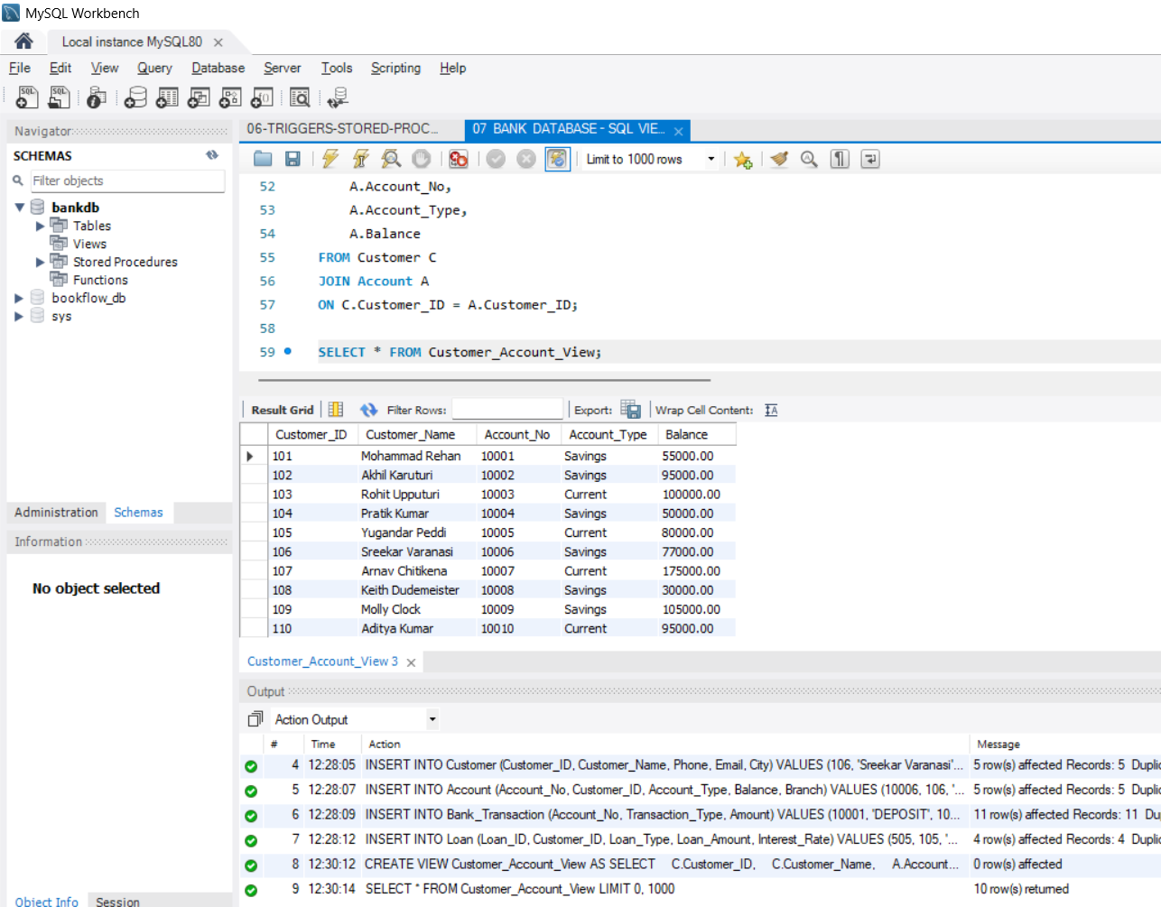

2. Savings Accounts > ₹50,000
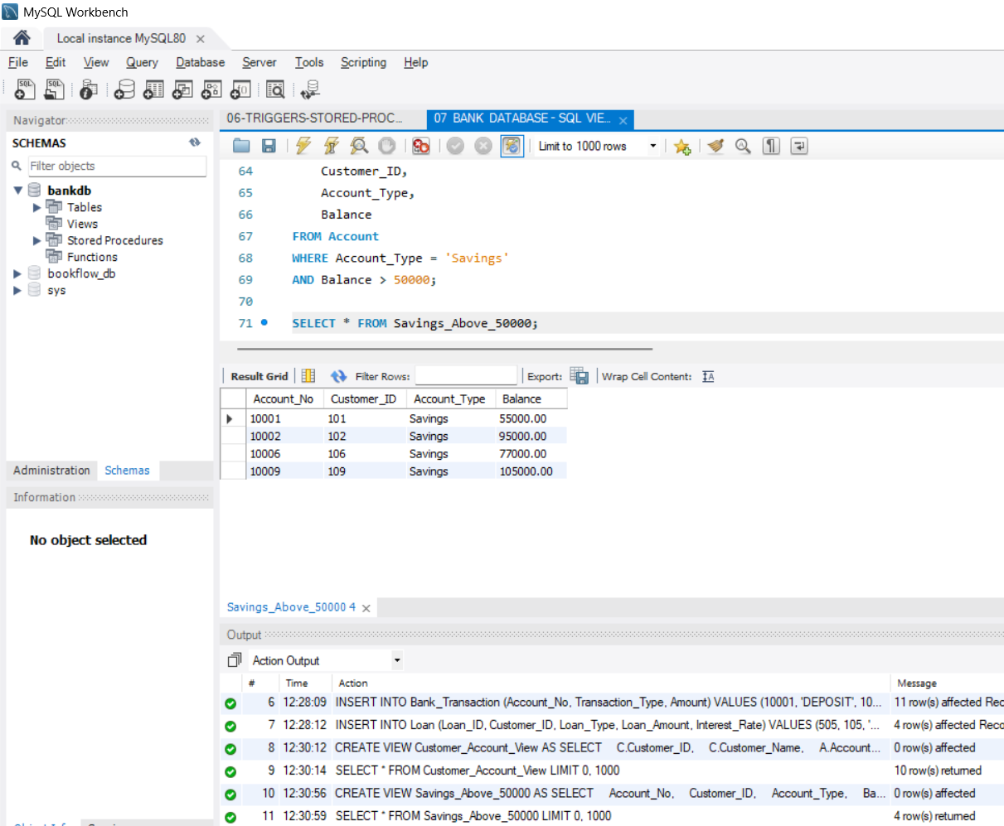

3. Customer + Account + Loan View
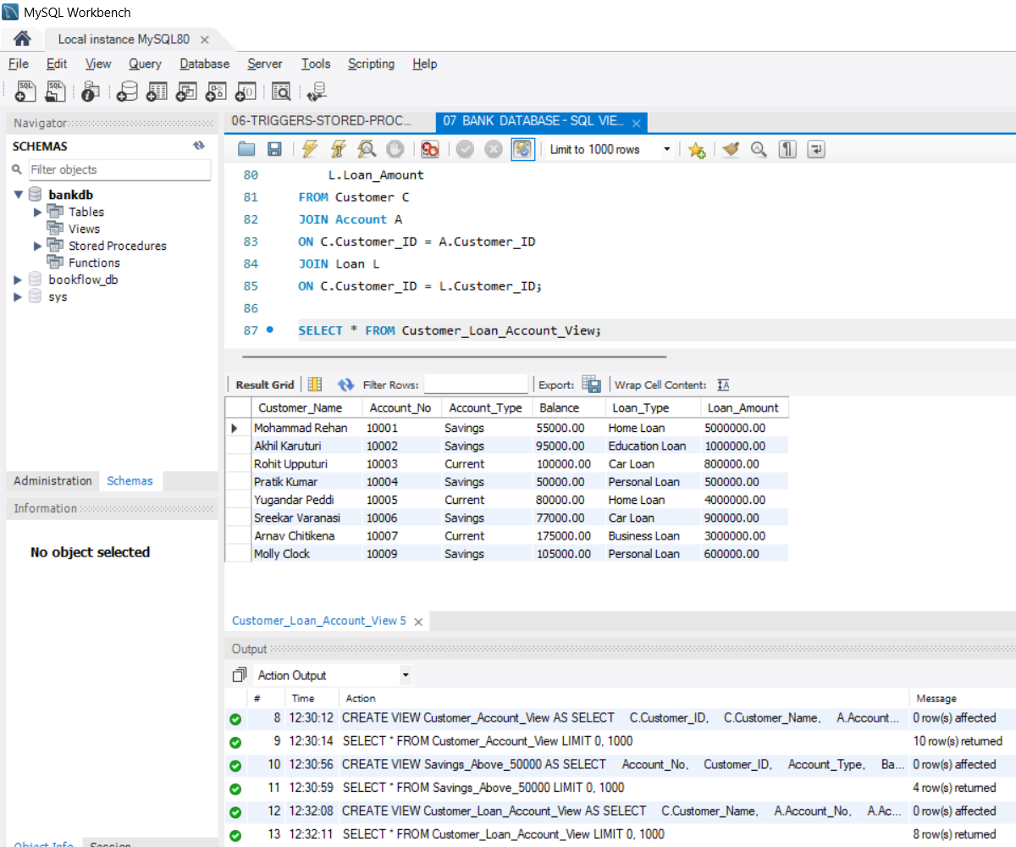
4. Branch-Wise Total Balance
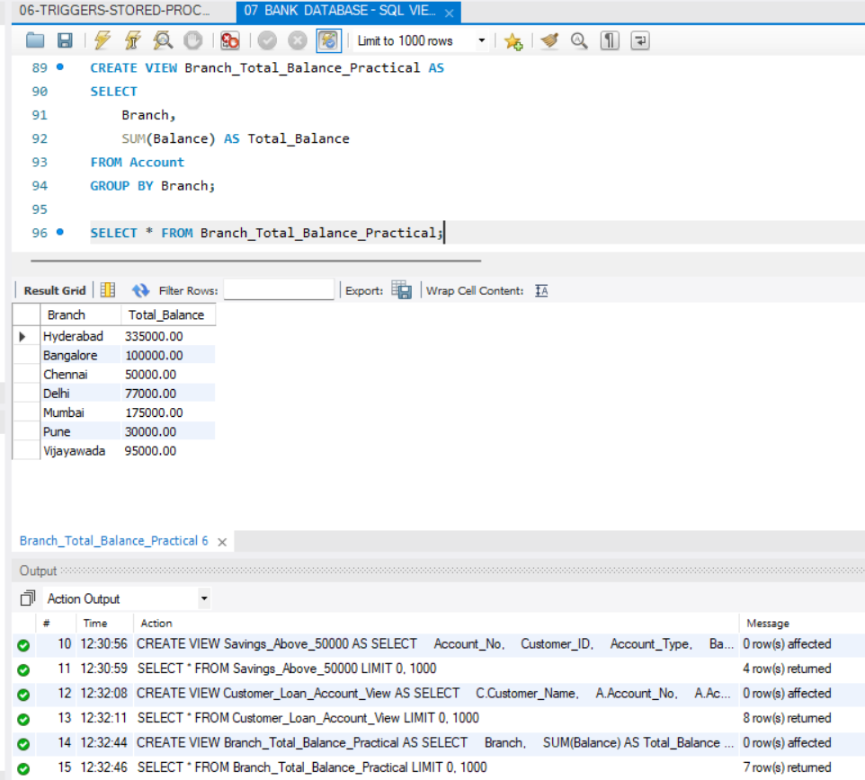
5. Annual Loan Interest
